# C3- S4 EXERCICE

Starting from this design (START_CODE.html) :

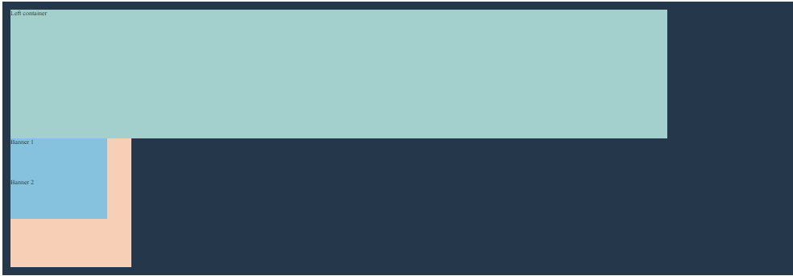

*Initial design*

We want to optain the following design :



*Final design*

For this exerccie you can use only the following rules:

* display: flex;
* justify-content: xxx
* flex-direction: xxx
* align-items: xxx

# TIPS !

Flexbox child element can also be a Flexbox container of **other elements**. Look at the final deisgn : we have a dark blue Flexbox container with two child elements.

The light orange box serves two purposes:

* it is the child element of the dark blue container
* but it is also a flexbox container itself, containing two lightblue child elements.

**STEP 1** : Apply rules on **.container class** to obtain the following result:

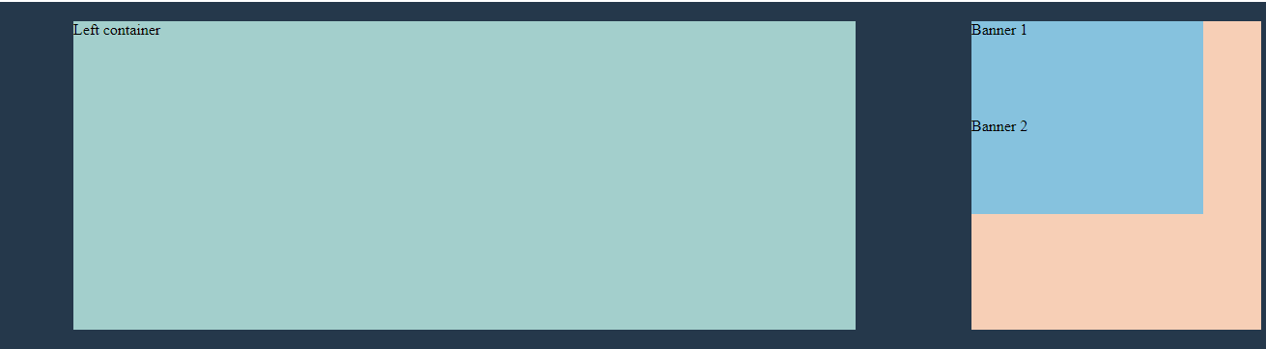

**STEP 2** : Apply rules on. **right-container** class to obtain the final result:

